**INSTALLATION GUIDE**

Install the Arduino Software (IDE) on Windows PC

* [Download the Arduino Software (IDE)](https://www.arduino.cc/en/guide/windows#toc1)
* [Proceed with board specific instructions](https://www.arduino.cc/en/guide/windows#toc2)

When the Arduino Software (IDE) is properly installed you can go back to the [Getting Started Home](https://www.arduino.cc/en/Guide/HomePage) and choose your board from the list on the right of the page.

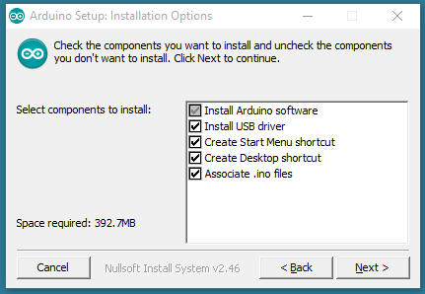

**Passive RFID**

* Primary Frequency Ranges: 860 - 960 MHz
* Read Range: Near Contact - 25 Meters
* Average Cost Per Tag: $0.09 - $20.00
* Applications: Supply Chain Tracking, Manufacturing, [Pharmaceuticals](https://blog.atlasrfidstore.com/7-things-can-track-hospitals-using-rfid?utm_source=RFID-Beginners-Guide&utm_medium=eBook&utm_campaign=Content&utm_content=hospital-applications), Electronic Tolling, Inventory Tracking, [Race Timing](https://blog.atlasrfidstore.com/all-about-the-timing?utm_source=RFID-Beginners-Guide&utm_medium=eBook&utm_campaign=Content&utm_content=race-timing),[Asset Tracking](https://blog.atlasrfidstore.com/rfid-asset-tracking-examples?utm_source=RFID-Beginners-Guide&utm_medium=eBook&utm_campaign=Content&utm_content=asset-tracking)
* Pros: Long Read Range, Low Cost Per Tag, Wide Variety of Tag Sizes and Shapes, Global Standards, High Data Transmission Rates
* Cons: High Equipment Costs, Moderate Memory Capacity, High Interference from Metal and Liquids

**Hardware Setup:**

Set the hardware and make connection as defined below-

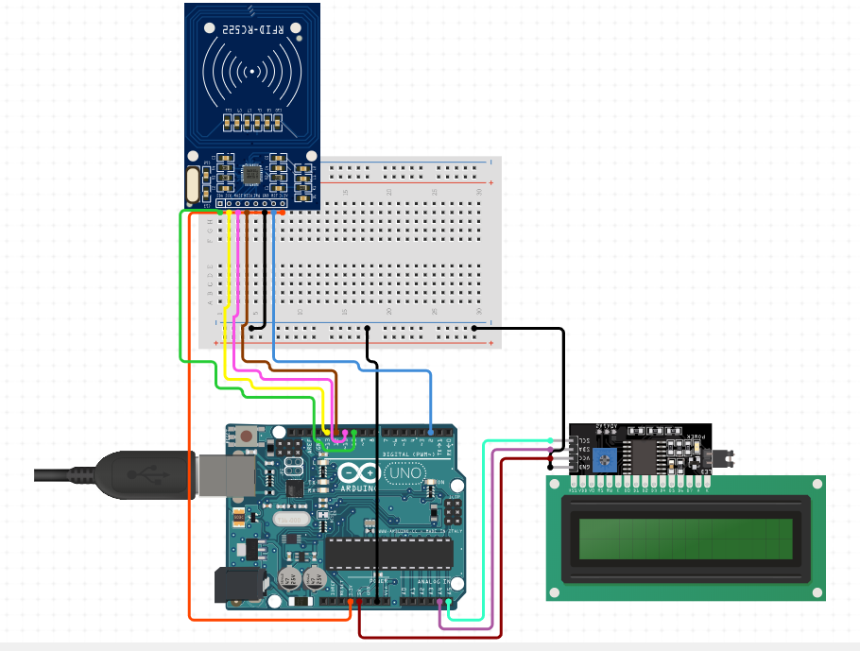

To run this part we need to generate a hex file on Arduino Uno which can further be used to compute output.

The code written on the IDE is shown below.

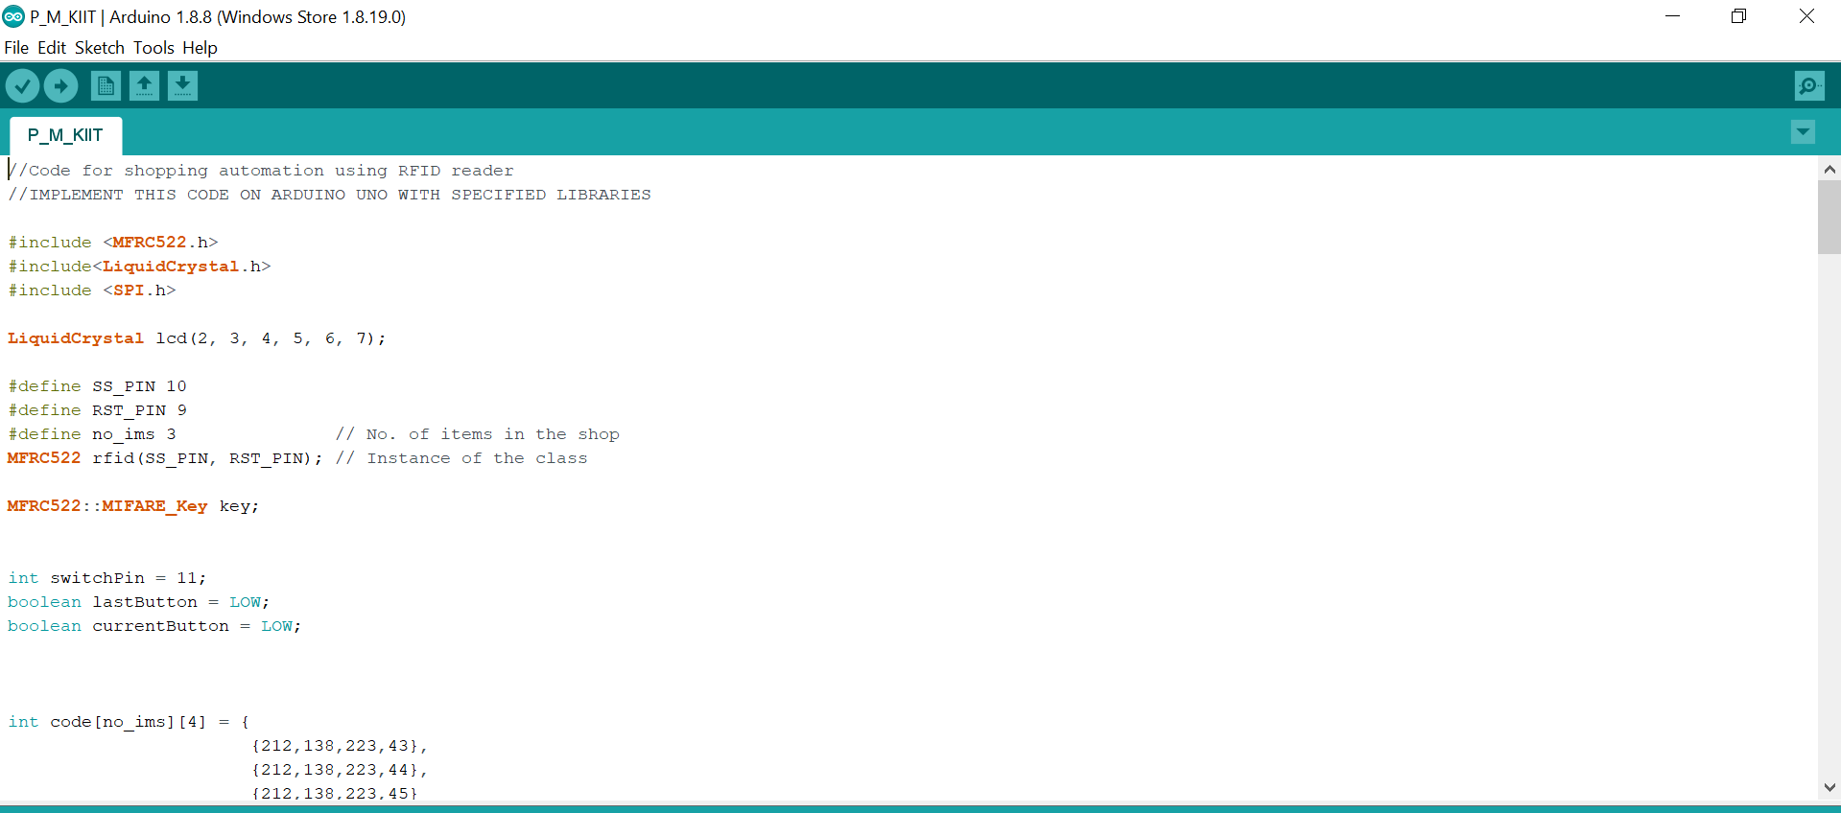

**LCD-16X2**

Output appears on the 16x2 LCD

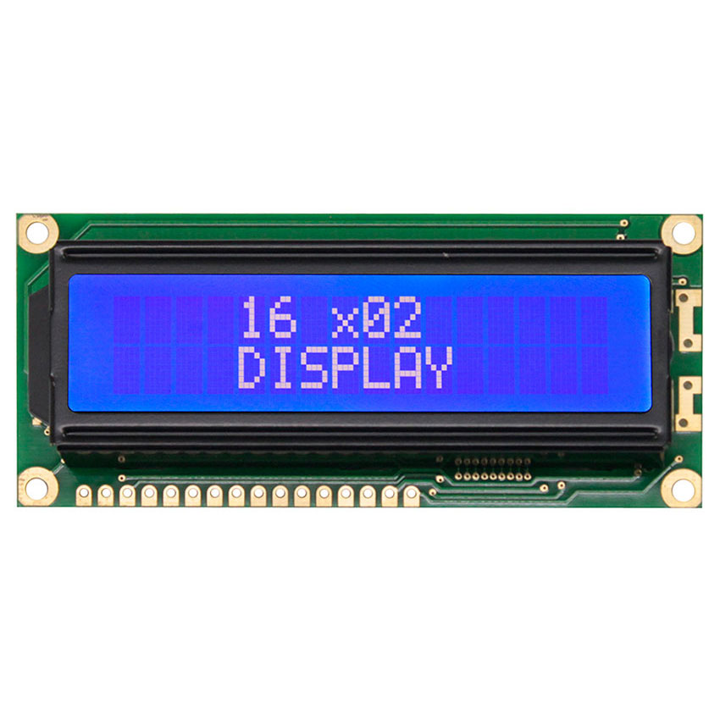

The new code will read. Go ahead and run this code to make sure everything is working. #include <LiquidCrystal.h>

LiquidCrystal lcd(7, 8, 9, 6, 4 , 3);

void setup() {

lcd.begin(16, 2);

lcd.setCursor(0,0);

lcd.write(" 16 x02");

lcd.setCursor(0,1);

lcd.write(" DISPLAY");

} void loop() { }

Now you should have the LCD and RC522 RFID module wired up. In case you missed something here are the Arduino pinouts:

* Pin 0 -
* Pin 1 -
* Pin 2 -
* Pin 3 - LCD D7
* Pin 4 - LCD D6
* Pin 5 - RFID RST
* Pin 6 - LCD D5
* Pin 7 - LCD RS
* Pin 8 - LCD E
* Pin 9 - LCD D4
* Pin 10 - RFID SDA
* Pin 11 - RFID MOSI
* Pin 12 - RFID MISO
* Pin 13 - RFID SCK

The first LCD function is used to display a Main Screen - This will be "Welcome" "Scan Your Card." This is the screen that will be shown if the reader has nothing present.

void lcdprintmain(){

lcd.clear();

lcd.setCursor(0,0);

lcd.write("Welcome");

lcd.setCursor(0,1);

lcd.write(" Scan Your Card");

}

RFID- RC522

For over a decade, radio‐frequency identification technology (RFID) has been the benchmark of technological innovation in scenarios of mass identification and traceability. RFID technology allows for identifying thousands of items in a few seconds, without direct line‐of‐sight between the RFID antennas (reader) and the items to identify (RFID tags), reaching up to 10 m of reading distance.

## RFID Interfacing to Arduino:

## [Picture of RFID Interfacing to Arduino:](https://cdn.instructables.com/FN7/3ZSZ/J4G54Q26/FN73ZSZJ4G54Q26.LARGE.jpg)

[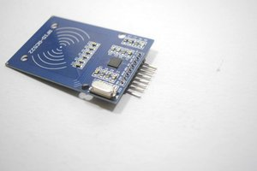](https://cdn.instructables.com/FYW/X25J/J4G54Q2W/FYWX25JJ4G54Q2W.LARGE.jpg)[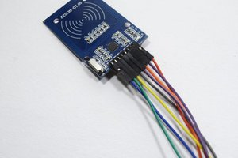](https://cdn.instructables.com/F43/CLR6/J4G54Q3N/F43CLR6J4G54Q3N.LARGE.jpg)

[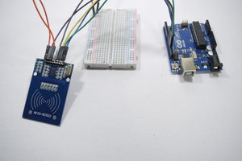](https://cdn.instructables.com/FZH/AYPN/J4G54Q4D/FZHAYPNJ4G54Q4D.LARGE.jpg)

As i explained in the initial stage of the intractable a RFID reader is a wireless technique used for the wireless communication where it is used to read or write a data over a RFID tag.

The pins explanation of the RFID reader as following order:

* 3.3V
* RST
* GND
* IRQ
* MSO
* MOSI
* SCK
* SDA

The connection of the RFID reader is given to the Arduino as follows:

* 3.3V is given to the 3.3v pin of Arduino
* RST is given to the digital pin 9
* GND is given to the ground pin of the Arduino
* IRQ is not connected
* MSO is connected to digital pin 12
* MOSI is connected to digital pin 11
* SCK is connected to the digital pin 10
* SDA is connected to the digital pin 9

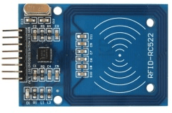 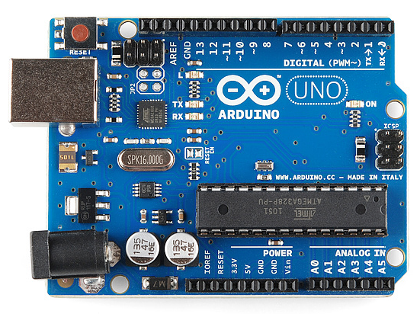

**Virtual simulation**

Further if we don’t want to virtually simulate this system we can do so in **proteus**. [Download link - <https://proteus.soft112.com/download.html>]

**Vspe** -Virtual serial port Emulator to create various virtual devices to transmit/receive data.

